NETNOPRAGMATICS: AN APPROACH TO ANALYZING THE USE OF LANGUAGE IN ONLINE COMMUNITIES

Yuliani Kusuma Putri

Abstrak
Artikel ini diajukan untuk memperkaya metode penelitian pada kajian pragmatis. Dengan memanfaatkan perkembangan teknologi dan kemajuan komunikasi, netnopragmatik diajukan sebagai sebuah pendekatan dalam menganalisis penggunaan bahasa dalam komunitas daring. Komunitas pada media sosial seperti Facebook dan Twitter, serta pesan instan seperti Skype dan WhatsApp dapat dijadikan objek penelitian dalam kajian pragmatis. Pendekatan ini tidak hanya menghemat waktu, data yang diperoleh melalui pendekatan ini juga lebih alami dibandingkan dengan data yang diperoleh melalui simulasi dan DCT. Peneliti netnopragmatik dapat menganalisis interaksi pada komunitas daring yang dilakukan melalui komunikasi bermedia komputer. Cabang-cabang ilmu pragmatik seperti tindak tutur, implikatur, dan kesantunan dapat dikaji melalui komunikasi bermedia komputer.
Kata Kunci: Netnografi, Pragmatik, Komunikasi Bermedia Komputer, Internet

Background
Our society has gone digital. Almost every aspect in our live is digitalised, such as digital libraries, digital classrooms, and digital communication. Because of the technological advancement, traditional communication, i.e. Face to Face (FtF) communication can be altered by modern communication, i.e. long distant communication. We can conduct a long distant communication using media such as corded or wireless phones, short message services, emails, instant messaging, and social media. The three latter media cannot work without an Internet connection. Such communication from such media is called computer-mediated communication (CMC).
CMC is now used as an alternative to FtF communication due to the distance between communicators. However, CMC can also be used as a pre-communication from FtF, such as arranging time and date to meet up. This is in line with what Perry (2010, p. 2) says that ‘CMC was being used to just say hello or chat, to coordinate schedules and routines, to plan future events or to discuss important matters’. CMC has a different style in language use from that of FtF, in a way that communicators can conceptualise what they are going to say before they actually say it; however, this does not apply when the communication is done via video or voice chat since the communication occurs simultaneously. Since CMC can be said to have several functions similar to those of FtF communication in certain aspects; then, in order to get a successful communication, it is important that communicators have good communication skills. One of the skills is the language skill.
CMC also triggers the development of online communities. In those communities, there are different styles of language use. This paper is going to propose a new approach to analysing the use of language in online communities using both pragmatic and netnography study first proposed by Kozinets (1997).

Computer-Mediated Communication
Computer-mediated communication (CMC) has become an integral part of our lives ever since the digitalization of our society in almost every aspect. CMC is now widely preferred because it is far less time and money consuming. Scharlott and Christ (1994) add that CMC can be useful to help people meet and form relationships, especially those who have met problems in doing so because of sex role, shyness, or appearance inhibitions (in Lane 1994).
What is computer mediated communication? Why does it differ from face to face interaction? CMC is defined as any kind of interaction conducted through a computer or network; CMC may involve forums, postings, instant messages, emails, chat rooms, and mobile text messaging (Kozinets, 2010, p. 189). CMC clearly differs from FtF communication in a way that CMC is done from a distance, and the communicators do not need to see each other in the same room and place. Another definition of CMC by Hine (2000, p. 157):

“A general term referring to a range of different ways in which people can communicate with one another via a computer network. Includes both synchronous and asynchronous communication, one to one and many to many interactions, and text based or video and audio communication”.

CMC is now preferred more to FtF communication by our society due to its practical and effective functions; CMC is cheaper, less time consuming, and can be done almost everywhere. CMC also allows users to have more freedom to express themselves compared to FtF communication. Some researchers also found that there was greater equality in CMC (Siegel et al., 1986; Rice and Love, 1987; McGuire et al., 1987; Bordia, 1997).¹ Lane (1994) shares his opinion that CMC:

“…has the greatest strength in the ability of the medium (computer) to store, process, and transmit messages to and from human beings. It allows for relatively inexpensive access to friends/students/family around the globe”.

There is a lot of research focusing on CMC. Some of them are done by Nitin et al. about flame classification, Lane (1994) about the use of CMC in classroom, Bordia (1997) about FtF versus CMC, Bicchieri and Lev-On (2007) about CMC and cooperation in social dilemmas,² Kozinets (2002) about marketing research in online communities, and Garcia et al. (2009) about ethnographic approach to the Internet and CMC. However, Walther (2011, p. 470) argues that the study of interpersonal communication is one of the challenges researchers on CMC encounter when many relationships are multimodal. His argument is answered by Kozinets (2002) and Garcia et al.’s (2009) research. They proposed the use of a qualitative study, i.e. ethnography, to analyse people’s communication in CMC. Kozinets (1997) even coined a neologism ‘netnography’ to refer to an ethnographic study of online communities in CMC.

Netnography
Netnography, short from network ethnography, is a term first coined by Kozinets (1997). The term is a neologism from a qualitative research method focusing on the study of online cultures and communities. Netnography, or ethnography on the network, is “a new qualitative research methodology that adapts ethnographic research techniques to the study of cultures and communities emerging through computer-mediated communication” (Kozinets, 2002, p. 2). The term netnography comes in many names, such as ‘online ethnography’ (Krumwiede and Meiers, 1991), ‘technography’ (Richardson, 1992), ‘hypermedia and ethnography’ (Dicks and Mason, 1998), ‘virtual ethnography’ (Hine, 2000), ‘digital ethnography’ (Murthy, 2008), and ‘ethnography and virtual worlds’ (Boellstorff et al., 2012). Netnography can be used as a tool for collecting data, the product of an investigation, or a combination of both.³ Researchers who are interested in conducting online investigation may use this method.
Researchers will be very much helped by netnography because it is an approach to investigate everyday life of groups of people, offers powerful resources for the study of the virtual world’s cultures (Boellstorff et al., 2012, p. 1). To add up, Garcia et al. (2011, p. 53) believe the incorporation of the Internet and CMC into ethnographers’ research is of importance to efficiently understand social life in contemporary society. Researchers can make themselves familiarised with the netnographic approach to help them study chats such as Skype, WhatsApp Messenger, and Line; blogs such as Tumblr, Blogspot, and Wordpress; even social networking sites such as Facebook, Twitter, and Path.
Since netnography adapts the techniques of ethnography research method, it can be an excellent resource for the experienced qualitative researchers and a beneficial entry point for the newcomers to qualitative research (Bowler, Jr., 2010, p. 1270). With the advances of technology, and the revolution of communication, many researchers feel the need to investigate the phenomena of online cultures and communities by adapting the techniques. Kozinets (2010) says that:

“New research on the use of Internet and other information and communication technologies (ICT) is adding significantly to the literature of cultural studies, sociology, economics, law, information science, business and management fields, communication studies, human geography, nursing and healthcare, and anthropology” (p. 3).

Moreover, Boellstorff et al. (2012) add that ethnography is also appropriate for those inhabiting a combination of computer science sub-disciplines, including human computer interaction, computer supported collaborative work, computer supported collaborative learning, and ubiquitous computing (p. 3). In addition, the development of cultures, communication, and communities online can also encourage linguistic researchers to conduct their research online.
In conducting netnographic research, participants in an online community are categorized into four types based on their participating frequency in the online community (Kozinets, 2010, p. 33). The first type of participants are newbies or tourists, i.e. members who lack strong social ties to the group, and merely have a superficial or passing interest in the consumption activity itself. Next type are minglers, i.e. the associates of the communities, socialisers who keep strong personal ties with many members of the community but who are only casually interested or drawn to the central consumption activity. The third type are devotees, who have few attachments to the online group yet strong consumption interests. Last type, insiders, have strong ties to both the online group and the consumption activity, and tend to be enduring and frequently referenced members (Kozinets, 2002, p. 6). Kozinets (2010) illustrates the types of online community participation as follows.
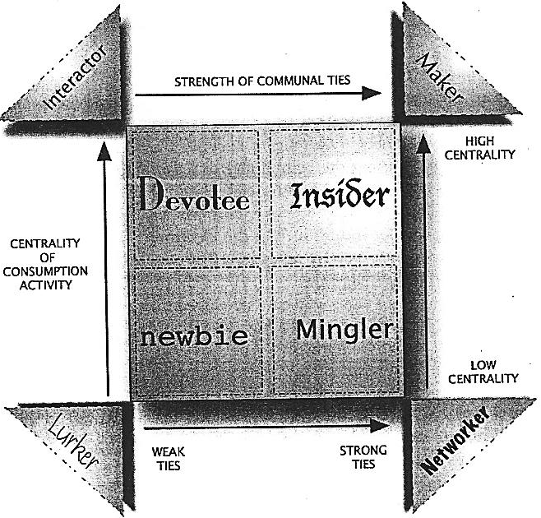
Figure 1 Types of online community participation (Kozinets, 2010, p. 33)

Netnography is “participant observational research based in online fieldwork” (Kozinets, 2010, p. 60). It means that netnography observes people on the Internet using computer-mediated communications as its data source to achieve ethnographic understanding and representation of a cultural or communal phenomenon. To help netnographers observe participants in an online community, there are some procedures similar to those of ethnography they may follow. Before conducting the participant observation, it is necessary that a netnographer start from the first step of netnographic research project. Figure 2 below illustrates the steps a netnographer should take in a netnographic research.
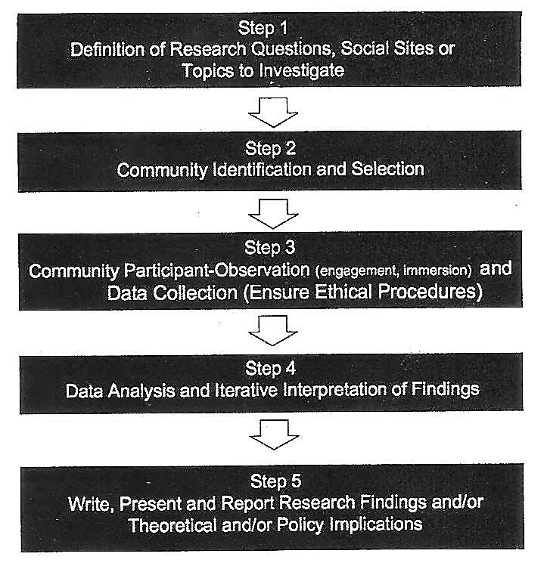
Figure 2 Flow of a netnographic research project (Kozinets, 2010, p. 61)

Similar to ethnography, in netnography, netnographers must first plan the research. They must find the online culture and community suitable for their research questions. This procedure is called entrée. Kozinets (2002, p. 4) further explains there are two steps netnographers should take in entrée. First, they must think of specific research questions and then identify particular online forums appropriate to the research questions. Second, they must thoroughly learn about the forums, the groups, and the individual participants they want to observe, which leads to the second step: community identification and selection. In selecting online culture and community, the sites netnographers choose to investigate often depend on common sense understandings of what the phenomenon being explored is, essentially connected to ideas about where the activity goes on, whether the activity be the technical work of software engineering or the experimental work of science (Low and Woolgar, 1993; Knorr-Cetina, 1992 in Hine, 2000 p. 58).
There are at least two important elements to the next step, community participant observation and data collection. First, the data that the netnographers copy from the computer-mediated communications of online community members directly. Second, the data the netnographers transcribe regarding his/her observations of the community, its member interactions and meanings (Kozinets, 2002, p. 5). Netnographers cannot only record textual data, but also record video or audio format using video or audio capturing software. Social media such as Facebook and Skype provide video capability built in the software, all netnographers have to do is install software for capturing video or audio on their computers. However, netnographers must remain alert to the possibility that participants may overact of feel self-conscious in the camera’s presence (Boellstorff et al., 2012, p. 116). In order to prevent this from happening, Jakobsson (2006) added a camera to his avatar when he recorded to graphically symbolise the act. What must netnographers also remember is the anonymity of participants if the video will be used in public lectures or disseminated in other ways (Boellstorff et al., 2012, p. 117).
In collecting data and observing participants, netnographers must remember to ensure the ethical procedures similar to those of ethnography. To take part in a newsgroup without revealing one’s role as a researcher would, as in all cases of concealed ethnography, pose a considerable ethical problem (Hine, 2000, p. 23). Kozinets (2010, p. 138–146) reminds netnographers what to consider, they are: 1) Internet Research Ethics (IRE); 2) public versus private fallacy; 3) consent in cyberspace; 4) harm online; 5) anonymity; and 6) legal considerations.
IRE is concerned with “philosophical matters, commercial interests, academic traditions of research practice and method, and institutional arrangements, as well as the oversight of legislative and regulatory bodies” (Kozinets, 2010, p. 139). Many researchers also debate about the public versus private post. Rafaeli (1995) summarised the consensus of a certain group of scholars debating the private versus public issue by stating that informed consent was implicit in the act of posting a message to a public area.⁶
In addition, Kozinets (2010) further adds procedures for ethical netnography, which is in line with the considerations. The procedures include identifying and explaining; asking permission; using commercial sites for netnography; gaining informed consent; citing, anonymising, or crediting research participants; and four degrees of concealment. In identifying and explaining, together with asking permission procedures, netnographers should reveal their presence, affiliations and intentions completely to online community members during any research (Kozinets, 2002, p. 9). Netnographers should also ask permission from members to conduct observation in the online community and should not begin the observation until the permission is granted. Netnographers can conduct a netnography research in commercial sites. Since commercial websites often contain extremely exciting and useful material, netnographers are often naturally attracted to them (Kozinets, 2010, p. 149). Commercial sites have also begun to use different sorts of legal means to limit individuals from access to online content, and there are many potential and popular sites for the conduct of netnography have limitations written into their terms of service agreements (Kozinets, 2010).
Netnographers must also ensure confidentiality and anonymity of informants. In anonymising or crediting netnographic research participants’ accounts, researcher’s goal is to fairly balance the rights of Internet users with the value of his/her research’s contribution to society (Bruckman 2002, 2006; Hair and Clark 2007; Walther 2002). Kozinets (2010, p. 153) says that netnographers need to balance the following ethical considerations: 1) the need to protect vulnerable human participants who may be put at risk from the exposure of a research study; 2) the accessible and ‘semi published’ qualities of much of what is shared on the Internet; and 3) the rights of individual community and culture members to receive credit for their creative and intellectual work. Furthermore, anonymity is needed to avoid public’s anger concerning inappropriate contents.
Finally, the final step of a netnographic research is to seek and incorporate feedback from members of the online community being researched. By using member checks, netnographers present some or all of their final research report to the people they have studied in order to solicit their comments (Kozinets, 2002, p. 9).

Pragmatics
Pragmatics is a branch of linguistics which studies meaning in interaction. According to Yule (1996, p. 3), pragmatics is concerned with the study of meaning as communicated by a speaker (or writer) and interpreted by a listener (or reader).
Yule (1996, p. 3) adds that pragmatics deals more with the analysis of what people mean by their utterances than what the words of phrases in those utterances might mean by themselves. Pragmatics studies what speaker means. This type of study includes the interpretation of what people mean in certain context and how the context plays a role in what is said. Thus, pragmatics also studies meaning in contexts. In addition, pragmatics tries to find out how a great deal of what is unsaid is recognised as part of what is communicated. On the other hand, pragmatics studies how more gets communicated than is said. This perspective then raises the question of what determines the choice between the said and unsaid. The basic answer is related to the concept of distance. Closeness, whether it is physical, social, or conceptual, implies shared experience. On the assumption of how close or distant the listener is, speakers determine how much needs to be said. In brief, pragmatics studies the expression of relative distance.
Taken together, pragmatics deals with contexts and utterances influencing speakers’ meaning. What speakers utter may differ in certain context that follows the utterance. Some of pragmatic subfields that can be investigated using netnography are implicatures, speech acts, and politeness.

Implicatures
Implicatures are intended meanings of utterances which are not explicitly stated in the act of utterance, nor do they follow logically from what is said (Cruse, 2006, p. 85). In an implicature, what a speaker utters does not literally mean the way it is uttered, it simply has an inferred meaning. This meaning is typically produced with a different logical form from what is uttered. To be able to understand implicatures, it is necessary to understand basic cooperative principle.
Grice (1975) first introduced basic cooperative principle as a result from his observation that conversational exchanges consist of cooperative efforts which incorporate the speaker’s intention and the hearer’s recognition of that intention. The cooperative principle means “making your contribution such as is required, at the stage at which it occurs, by the accepted purpose or direction of the talk exchange in which you are engaged” (Levinson, 1983, p. 101). Grice proposed four conversational maxims governing the rules of conversation: 1) quantity: do not make your contribution more informative than is required; 2) quality: do not say what you believe to be false or that for which you lack evidence; 3) relation: be relevant; and, 4) manner: be brief and orderly.⁷
There are two basic kinds of implicature: 1) conventional implicatures are those which have a stable association with particular linguistic expressions such as yet in Jane hasn’t collected her assignment yet, which implicates that Jane is still expected to collect her assignment; and 2) conversational implicatures are those which must be inferred, and for which contextual information is crucial such as the expression Mum already cooked in reply to the statement I’m going to make lunch, which implicates that it is not necessary to cook since mother already did.
Speech act refers to an act made when an utterance is proposed; for example, giving orders and making promises (Austin, 1962). Searle (1969) shares, “Speech acts are the basic unit of linguistic communication” (p. 16). The minimal unit of linguistic communication is not linguistic expression, but rather the performance of certain kinds of acts. When people utter a sentence, it is not just to say things but rather actively to do things. There are sorts of things that can be done with words, such as make requests, ask questions, give orders, and make promises.
According to Félix-Brasdefer (2008, p. 37), languages have various linguistic resources for communicating speech acts. Speech acts can be realised explicitly using performative verbs or speech act verbs (e.g., I apologise, I refuse, I promise, etc.). However, it should be considered that not all speech acts may be realised using speech act verbs, as one cannot use the verb ‘to insult’ to explicitly insult someone (e.g., ‘I insult you!’); but rather, speakers may employ other linguistic resources to express the illocutionary force of a speech act. Hence, speech acts can be performed through either utterances or other linguistic instruments.
There are five three levels of speech acts according to Austin (1962): 1) locutionary act, which has to do with the utterance that is presented by a sentence with a grammatical structure and meaning; 2) illocutionary act, deals with the intention of the utterance, such as stating, questioning, commanding, or promising; and 3) perlocutionary act, the bringing about of effects on the audience by means of uttering the sentence, such effects being special to the circumstances of utterance. Of these three levels, based on Yule (1996, p. 49), the most discussed is illocutionary force. The term ‘speech act’ is generally interpreted quite narrowly to mean only the illocutionary force of an utterance. The illocutionary force of an utterance is what it ‘counts as’.
Searle (1969, p. 240) proposes taxonomy that there are five basic kinds of action that one can perform in speaking: 1) representatives is to commit the speaker to the truth of the expressed proposition, such as asserting, concluding, and suggesting; 2) directives is speech acts which attempt the addressee to carry out an action, for example; requesting, questioning, and commanding; 3) commisives is speech act which commit the speaker to some future action like promising, threatening, offering, and pledging; 4) expressives is to express a psychological state or attitude like thanking, welcoming, and congratulating; 5) declarations which bring about the state of affairs they name, such as marrying, blessing, and firing.⁸
In terms of indirectness, there are two types of speech acts; direct and indirect speech acts. Yule (1996) states that a direct speech act is an utterance that is performed by the speakers which means exactly and literally. It means that in uttering something, the speakers say what they mean and mean what they say. Thus, both the speakers and the hearers can understand what the utterance implies. For example, the utterance “Please take out the garbage” is a direct request for the hearer to take out the garbage.
An utterance can be recognised as an indirect speech act if the literal meaning of the locution differs from its intended meaning. Searle (1975) introduced the idea of an 'indirect speech act'. He describes indirect speech acts as follows:

“In indirect speech acts the speaker communicates to the hearer more than he actually says by way of relying on their mutually shared background information, both linguistic and nonlinguistic, together with the general powers of rationality and inference on the part of the hearer”.

Speakers may consider using either direct or indirect speech acts based on the hearers’ status and/or distance. In order to respect the hearers, speakers may express their speech acts along with their politeness.

Politeness
As far as linguistic behaviour is concerned, politeness deals with efforts to reduce the negative effects of one’s utterance on the feelings of others and to gain positive effects. Cruse (2006, p. 131) adds that politeness can also be both speaker oriented and hearer oriented. In addition, Grundy (2000) further explains that politeness phenomena also extend the concept of indexicality because they demonstrate that every utterance is uniquely designed for its audience (p. 145). There are two types of politeness: positive and negative politeness.
A positive politeness strategy brings the requester to get the mutual goal, and even friendship. The linguistic behaviour of positive politeness is simply the normal behaviour between intimates. Negative politeness, on the other hand, is “compensative action addressed to the addressee’s negative face: his want to have his freedom of action unhindered and his attention unimpeded” (Brown and Levinson 1987, p. 129). Yule (1996) elaborates that when speakers use positive politeness forms, they tend to emphasise closeness between them and hearers. It can be seen as a solidarity strategy that may contain personal information such as nicknames, and shared dialect or slang expressions (p. 65-66). On the other hand, when speakers use negative politeness forms, they tend to emphasise the hearers’ right to freedom and it can be seen as a deference strategy that may involve ‘formal politeness’. The following table illustrates the choice of strategies in positive and negative politeness.

Table 1 Brown and Levinson’s politeness strategies (in Grundy, 2000, p. 161)
Positive Politeness | Negative Politeness
Notice/attend to hearer’s wants  Exaggerate interest/approval  Intensify interest  Use in group identity markers  Seek agreement  Avoid disagreement  Presuppose/assert common ground  Joke  Assert knowledge of hearer’s wants  Offer, promise  Be optimistic  Include speaker and hearer in the activity  Give (or ask for) reasons  Assume/assert reciprocity  Give gifts to hearer (goods, sympathy, etc.) | Be conventionally indirect  Question, hedge  Be pessimistic  Minimise imposition  Give deference  Apologise  Impersonalise  State the imposition as a general rule  Nominalise  Go on record as incurring a debt

Theory in Practice
Given the theoretical points explained in the previous sections, this section will elaborate studies in pragmatics that can be done to online cultures and communities by adapting netnography method. In reference to the explanations about implicatures, speech acts, and politeness, the most appropriate data analysis procedure is pragmatic-interactionist approach (Kozinets, 2010, p. 132). Pragmatic-interactionist approach is an analysis which unit is not the person, but the gesture, the behaviour or the act, including the speech act or utterance (Mead, 1938 in Kozinets, 2010).
Netnopragmatics is proposed in this article since it is in line with the pragmatic-interactionist approach. Similar to pragmatic-interactionist approach, netnopragmatics is proposed with several considerations, such as: (1) online world functions as a social environment; (2) online data as social acts; (3) finding out the meaning of the acts in accordance with the context that precedes or follows. The term netnopragmatics refers to a pragmatic study on language use by online community members. By conducting a netnopragmatic study, the data analysis involves “contextualising the meaning of the exchange and interaction in ever-widening circles of social significance” (Kozinets, 2010, p. 133). In netnopragmatics, various kinds of visual data can be analysed: moving graphical images or emoticons, colours, type font, pictures and photographs, and layout of pages and messages.
Online communities may exist on blogs, Facebook, Twitter, even instant messaging groups such as WhatsApp, BlackBerry Messenger, and Line Messenger. In this article, one Facebook group is taken as an example for the implementation of netnopragmatic study.
In conducting a netnographic research on implicatures, netnopragmatists can study communications between members of the same Facebook group. Netnopragmatists can sneak into, or better yet, become a member of the group to observe each member’s interactions on the group board or even on his/her timeline. They may study about, say, maxim violations together with a thorough context that elaborates why such violations occur.
In addition, the study of speech acts in online communities can also be done using netnopragmatics. This is in line with Kozinets (2010) that any kinds of postings such as photographs, videos, pictures, and tags can be taken as an utterance, and are akin to a ‘speech act’. Speech acts such as compliments, invitations, apologies, refusals, and offers can be analysed by observing members of an existing online culture and community. By using social media for observation, netnopragmatists are also able to decide the ‘ties’ of relation between members, i.e. the degree of solidarity, relative power, and/or absolute ranking of impositions (Brown and Levinson 1987), which may affect the choice of strategy in uttering the acts. This ‘ties’ are also helpful for politeness study. The following is an example of analysis on both implicatures and speech acts occurring in a Facebook group.

Context:
The interaction occurred in a Facebook group of linguists: students, practitioners, and researchers from all over the world. This clearly shows that members of the group come from different cultural backgrounds. There are 16,930 members with 6 admins. The number of members joining the group and the variety of backgrounds indicate that not all members have interpersonal relationships among other members, therefore they cannot decide the relative power or ranking of imposition whatsoever. There are approximately 150 active members who post and reply to posts in the group. Based on Kozinets’s types of online community participation, there is only one devotee member, FRH, who often replies to posts and posts linguistic information. Other 149 members are simply minglers. Even though the 6 admins are insiders, they are not as much active as FRH.

Data:



Analysis:
The interaction occurred on 7 October at 23:09 and involved three members. AHL was the person who initiated the conversation. His initiation can be taken as a speech act of command, despite the sentence structure which is in a form of declarative. He wanted the members to help him find out terms related to language death (Hi guys, explain some terms related to language death). The speech act AHL gave is a command because from his utterance, he did not put a subject and simply gave the verb ‘explain’ after his greetings ‘hi guys’.
The first member to reply AHL’s initiation was CA on 8 October at 09:31. The reply CA gave to AHL, from implicature point of view, showed that CA just violated the maxim of relation, which requires speakers to be relevant. However, from speech act point of view, CA’s reply is actually a request that AHL say the ‘magic word’ (Where’s the magic word?). It is assumed that CA came from a culture in which when one makes a request, one should also express the politeness.
AHL then replied to CA’s response by maintaining the maxim of quantity, which requires to be as informative as is required. However, there is a misunderstanding between CA and AHL. CA uttered the question as a request that AHL say the ‘magic word’. AHL took the question literally as a question and answered it (It’s “language death”).
FRH then joined the conversation and asserted that CA’s utterance is actually a request for AHL to say ‘please’ (That’s typically a request for the word “please”). FRH’s speech act of asserting indicates that he came from the same culture as CA. Even though FRH’s response violated the maxim of relation, it confirmed the misunderstanding between CA and AHL. It can be clearly seen that conversational implicatures do not always go in line with speech acts.

Not only in implicatures and speech acts, in studying politeness, ‘ties’ can also be used to explain what type of politeness a member uses to communicate with another member or other members and why such politeness is preferred. Netnopragmatists may observe the choice of politeness strategy and decide the degree of familiarity or closeness between members. The study of politeness can also be examined through the choice of words, phrases, or sentences each member of an online community prefers to use. The following is an example of analysis on both implicatures and speech acts occurring in the same Facebook group.
Context:
The interaction occurred in a Facebook group of linguists: students, practitioners, and researchers from all over the world. This clearly shows that members of the group come from different cultural backgrounds. There are 16,930 members with 6 admins. The number of members joining the group and the variety of backgrounds indicate that not all members have interpersonal relationships among other members, therefore they cannot decide the relative power or ranking of imposition whatsoever. There are approximately 150 active members who post and reply to posts in the group. Based on Kozinets’s types of online community participation, there is only one devotee member, FRH, who often replies to posts and posts linguistic information. Other 149 members are simply minglers. Even though the 6 admins are insiders, they are not as much active as FRH.

Data:
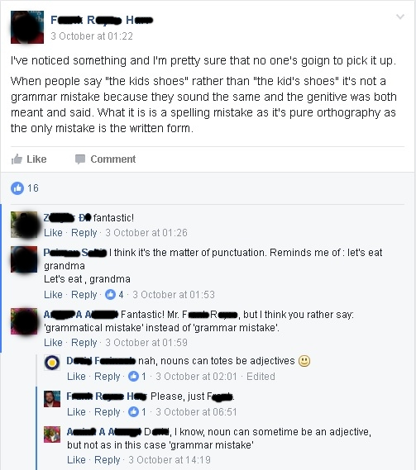

Analysis:
The conversation was initiated by FRH who wrote a post in the group’s timeline on 3 October at 01:22. His post was responded by four members. One of the members, AAA, responded FRH by an exclamation (Fantastic!), followed by a statement which consists of a negative politeness (Mr. FRH, but I think you rather say: ‘grammatical mistake’ instead of ‘grammar mistake’). AAA addressed FRH with ‘Mr.’ as her politeness. The negative politeness she gave indicates that the ‘tie’ between FRH and her is loose. Nevertheless, FRH then replied AAA stating that she should address him simply with his first name. FRH prefers the positive politeness instead of the negative one.

In netnopragmatic study, it is important to note that in order to gain more naturalistic data and avoid being considered a lurker, a netnopragmatist had better become a member of the online community. However, a netnopragmatist must also concern about the research ethics in netnography despite the membership he/she has in that online community. Research ethics for the data taken in this article have been considered in a way that the names and faces of the members are concealed.

Conclusions and Suggestions
Netnography is a suitable method a pragmatist can use to analyse the use of language in virtual worlds by online communities. There are several techniques in collecting research data a netnopragmatist can choose appropriate with their research questions and aims. By following the procedures and guidelines of netnographic study, netnopragmatists will be very much helped in conducting their research online with less time consuming.
This paper is merely an idea and it is important to stress that the suggestions presented have only been tested or applied in some studies conducted by the writer. It is strongly suggested that fellow pragmatists conduct this kind of research and put the idea into practice.

End Notes:
- In CMC groups, participation tends to be more balanced or equitable.
- Face to face positively affects cooperation. Similar to FtF, CMC also has a positive effect to the cooperation in social dilemmas, but cooperation is more difficult to establish and maintain.
- Girginova, K. 2012. Introducing Digital Ethnographies. Retrieved from http://gnovisjournal.org/2012/10/09/introducing-digital-ethnographies/
- In Kozinets (2010: 44)
- In Boellstorff et al. (2012: 105)
- In Kozinets (2002: 8)
- For more about cooperative principle, read Grice, H. P. 1975. Logic and conversation. In P. Cole & J. Morgan (Eds), Syntax and semantics 3: Speech acts (pp. 41–58). New York: Academic Press.
- Improving Austin’s categories of speech acts (1962), which are verdictives, exercitives, commisives, expositives, and behavities.

REFERENCES

Austin, J. L. (1962). How to Do Things with Words. Oxford: Oxford University Press.
Bicchieri, C. & Lev-On, A. (2007). Computer-Mediated Communication and Cooperation in Social Dilemmas: An Experimental Analysis. Politics, Philosophy & Economics 1470-594X 200706 6(2) 139-168. London: Sage Publication.
Boellstorff, T., Nardi, B., Pearce, C. & Taylor, T. L. (2012). Ethnography and Virtual Worlds: A Handbook of Method. USA: Princeton University Press.
Bordia, P. (1997). Face-to-Face Versus Computer-Mediated Communication: A Synthesis of the Experimental Literature. The Journal of Business Communication, Volume 34, Number 1, January 1997 99-120. Association for Business Communication.
Bowler, Jr. G. M. Netnography: A Method Specifically Designed to Study Cultures and Communities Online. The Qualitative Report Volume 15 Number 5 September 2010 1270-1275.
Brown, P. & Levinson, S. C. (1987). Politeness Some Universals in Language Usage. Cambridge: Cambridge University Press.
Cruse, A. (2006). A Glossary of Semantics and Pragmatics. Edinburgh: Edinburgh University Press.
Félix-Brasdefer, J. César. (2008). Politeness in Mexico and the United States. Philadelphia: John Benjamins Publishing Company.
Garcia, A. C., Standlee, A. I., Bechkoff, J. & Cui, Y. (2009). Ethnographic Approaches to the Internet and Computer-Mediated Communication. Journal of Contemporary Ethnography Volume 38 No. 1 February 2009 52-84.
Gass, S. M. & Neu, J. (1995). Speech Acts Across Cultures. Berlin: Mouton de Gruyter.
Grundy, P. (2000). Doing Pragmatics. Second Edition. London: Arnold Publishers.
Hine, C. (2000). Virtual Ethnography. London: Sage Publications Ltd.
Ishihara, N. & Cohen, A. D. (2010). Teaching and Learning Pragmatics: Where Language and Culture Meet. Great Britain: Pearson Education Limited.
Kozinets, R. V. (2002). The Field Behind the Screen: Using Netnography for Marketing Research in Online Communities. Journal of Marketing Research No. 39 February 2010 61-72.
______________. (2010). Netnography: Doing Ethnographic Research Online. Thousand Oaks, CA: Sage Publications.
Lane, D. R. (1994). Computer-Mediated Communication in the Classroom: Asset or Liability? Interconnect ’94 Teaching, Learning & Technology Conference October 14, 1994.
Leech, G. (1983). Principles of Pragmatics. New York: Longman Inc.
Levinson, S. C. (1985). Pragmatics. Cambridge: Cambridge University Press.
Perry, M. (2010). Face to Face Versus Computer Mediated Communication Couples Satisfaction and Experience Across Conditions. Unpublished Thesis. Kentucky: University of Kentucky.
Searle, J. R. (1969). Speech Acts: An Essay in the Philosophy of Language. Cambridge: Cambridge University Press.
___________. (1975). Indirect Speech Acts. Dalam P. Cole and J. Morgan (Eds.), Syntax and Semantics, vol. 3: Speech Acts (hal. 59–82). New York.
___________. (1981). Expression and Meaning: Studies in the Theory of Speech Acts. USA: Cambridge University Press.

Walther, J. B. (2011). Theories of Computer-Mediated Communication and Interpersonal Relations. In M. L. Knapp and J. A. Daly. The SAGE Handbook of Interpersonal Communication (4th Ed.). 443-479. Thousand Oaks, California: Sage Publications.
Yule, G. (1996). Pragmatics. Oxford: Oxford University Press.

